Gimp Tricks

Source:

http://www.youtube.com/user/GIMPtricks

Shavit Ilan

Removing picture background

- Add alpha channel
- Duplicate layer
- In original layer: color → curves
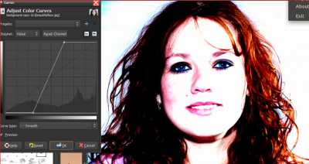
- Make the best possible contrast (background almost in white, Hair in Black)
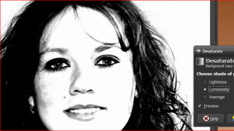
- Color → Desaturate
Choose the option that give the best contrast option
- Color → Invert
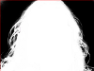
- Paint in white the required object
- In the main layer:
Right click → add layer mask
- Cut the upper layer and paste it to the layer mask
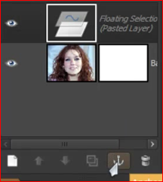
- Click on 'Anchor the floating layer'
- To fix the hair color (in the edges):
In main layer use the clone tool: copy the required color and clone it to the hair edges

Add Alpha Channel
Layer → Add Alpha Channel
add transparency to the layer.
- Without alpha channel:
delete a selection from the picture paint it in the background color
- With alpha channel:
delete a selection from the picture make this selection transparent

Remark:
- Layer without transparent layer written in bold
- Layer with transparent layer written in bold.

Sketch Effect
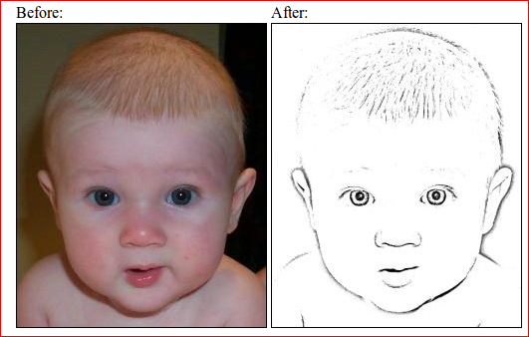
- Duplicate the layer
- Gaussian Blur the top layer with an appropriate radius (7 in this example). Generally, larger radius => "fatter" lines in the final sketch
- Image->Colors->Invert
- Adjust the Layer's Opacity to 50%
- Right-click on the top layer and pick Merge Down
- Layer → Colors → Levels to increase the contrast a bit, so that it's easier to inspect visually. In this example, I set Input Levels to 100-155;
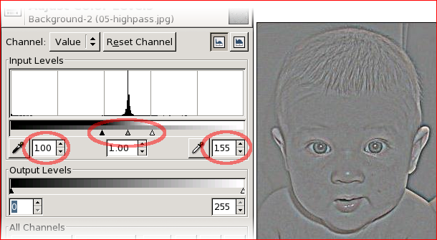
- Layer → Colors → Desaturate
the image
- Open Levels tool again. find out the best values for your image.
You most likely want to set max Input Level (the right value) to 128. The primary target of experimentation would be the gamma value field in the middle (the grey triangle just below the histogram). With a bit of tweaking, you could end up with something like this:
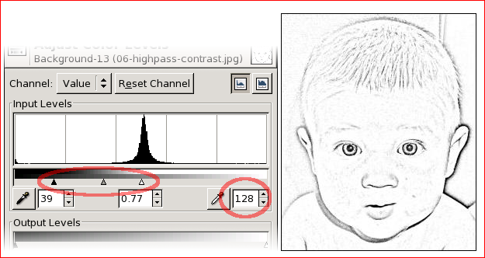

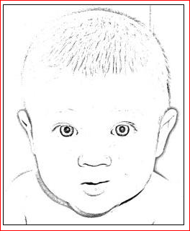
- Hand-polish the images to get rid of various imperfections:
Contrast the image. The higher the contrast, the stronger the lines. You can also fine-tuned the overall contrast (with Levels) to get rid of some of the noise in the face

- Finally scattered around his face by manually hand-brushed parts of it, giving the final result
